CS543 Assignment 4

**Your Name:** Derek Yang

**Your NetId:** mcy3

# Part 1 Single-View Geometry:

Plot the VPs and the lines used to estimate them on the image plane using the provided code.

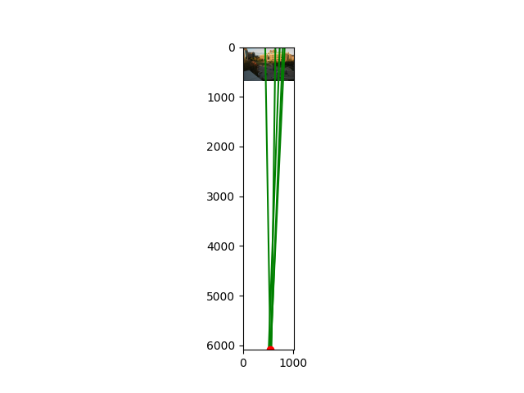

Specify the VP pixel coordinates.

Every column is a vanish point.

Plot the ground horizon line and specify its parameters in the form a * x + b * y + c = 0. 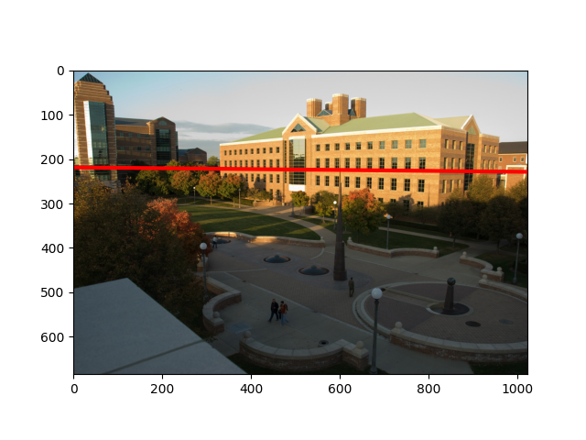

Normalize the parameters so that: a^2 + b^2 = 1.



Using the fact that the vanishing directions are orthogonal, solve for the focal length and optical center (principal point) of the camera. Show all your work.

Using the equation” v_i^TK^(-T)K^(-1)v_j = 0 ” with the three orthogonal vanishing point we can solve for the focal length and optical center.

Compute the rotation matrix for the camera.

Estimate the heights of (a) the CSL building, (b) the spike statue, and (c) the lamp posts assuming that the person nearest to the spike is 5ft 6in tall. In the report, show all the lines and measurements used to perform the calculation.

How do the answers change if you assume the person is 6ft tall?

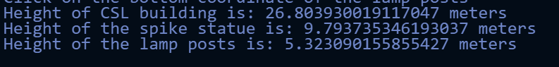

# Part 2 Fundamental Matrix Estimation, Camera Calibration, Triangulation:

## For the lab and library image pairs, display your result (points and epipolar lines) and report your residual for both unnormalized and normalized fundamental matrix estimation.

## 

Normalized

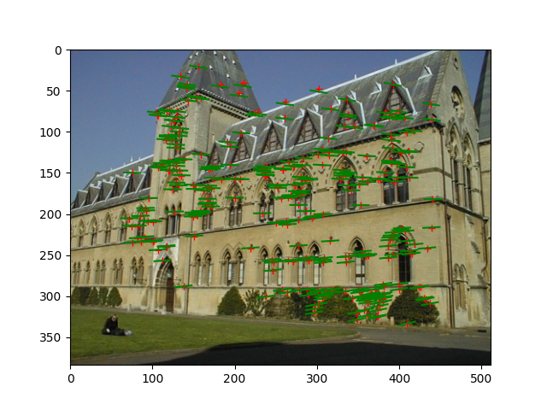

Not Normalized

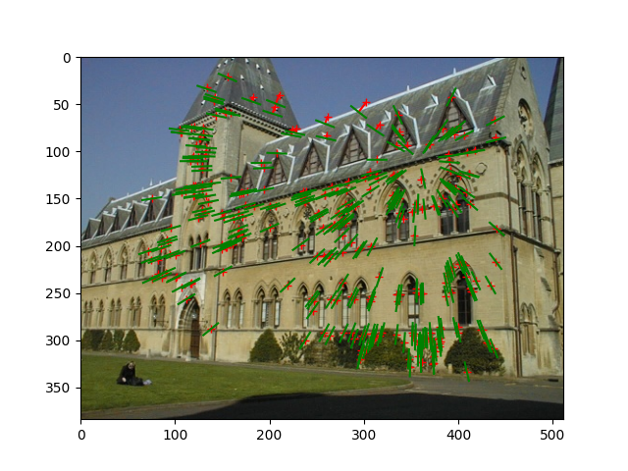

The top is the residual for normalized.

Bottom is the residual for not normalized.



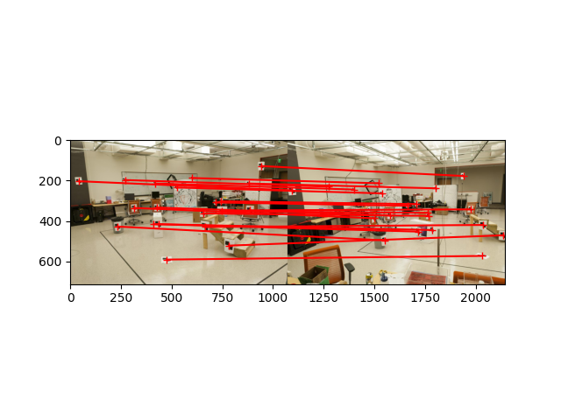

Normalized

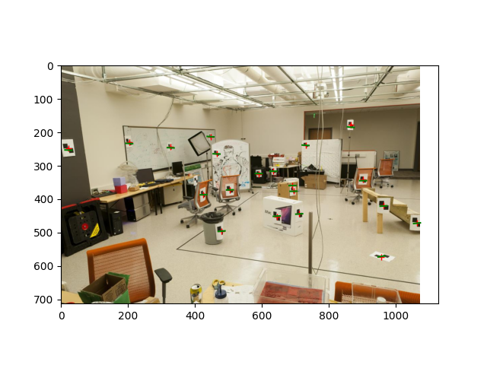

Not Normalized

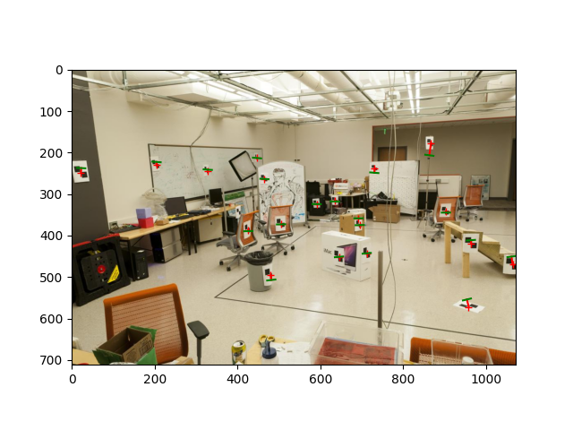

The top is the residual for normalized.

Bottom is the residual for not normalized.



## For the lab image pair, show your estimated 3x4 camera projection matrices. Report the residual between the projected and observed 2D points.

## For the lab and library image pairs, visualize 3D camera centers and triangulated 3D points.

## 

## Lab

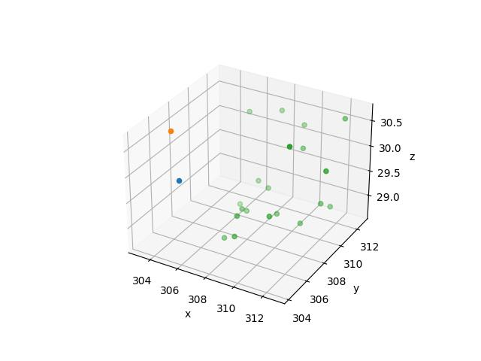

Library

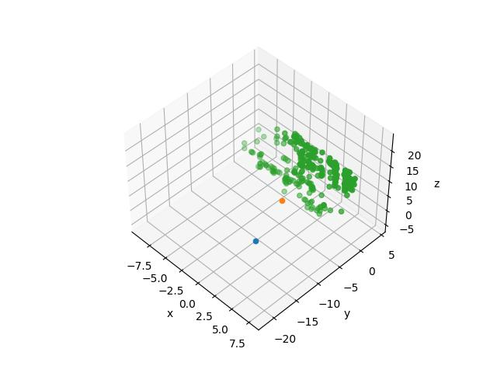

Below shows the camera center coordinates and the error for the Lab and Library respectively

## For the house and gaudi image pairs, display your result and report your number of inliers and average inlier residual for normalized estimation without ground truth matches.



